Frog Life Cycle

Drag the pictures to make a frog life cycle. Label the stages

C:\Documents and Settings\jholderbaum\Local Settings\Temporary Internet Files\Content.IE5\PBDGUU2L\MC900133545[1].wmf[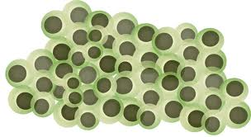](http://www.google.com/imgres?imgurl=http://www.edupic.net/Images/ScienceDrawings/frog_eggs.gif&imgrefurl=http://www.edupic.net/sci_gr.htm&usg=__Wz0XUAR-uot0Z5k-DmupeVyu0lY=&h=415&w=758&sz=144&hl=en&start=11&zoom=1&tbnid=yeH1GAxqVh5njM:&tbnh=78&tbnw=142&ei=XmHNTZeRNtDOgAfJ8ZmwDA&prev=/search?q=frog+egg+picture&um=1&hl=en&sa=N&rls=com.microsoft:en-us&rlz=1I7ADSA_en&biw=1260&bih=769&tbm=isch&um=1&itbs=1)

Name: