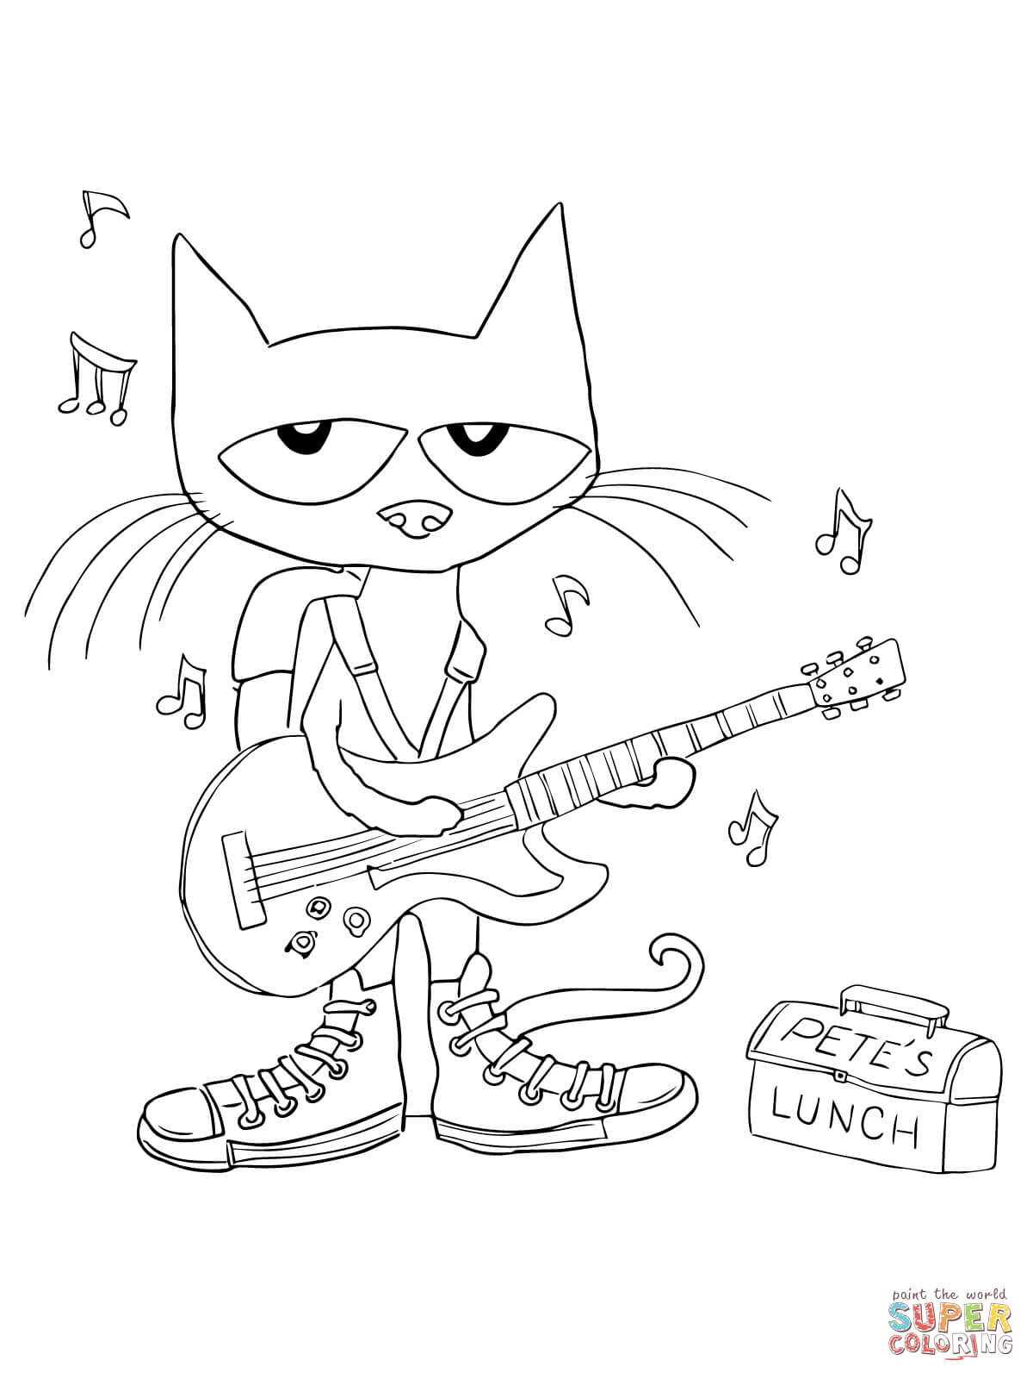

Name:

red

orange

yellow

green

blue

purple

pink

I like my shoes.