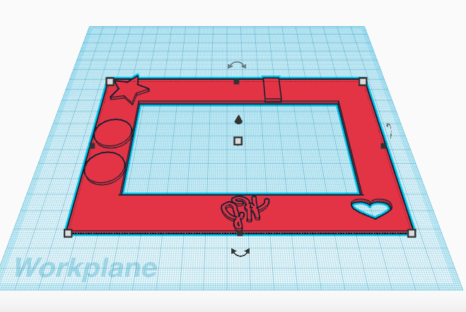

Distance Inside: 70mm

Distance Inside: 120mm

Thickness of shapes: 2mm

Thickness: 2mm

Distance: 110mm

Distance outside: 160mm