Name:
Turkeys are

big
small
brown
colorful
fast
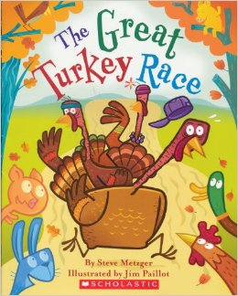
slow
yummy
silly
birds
Name:
Turkeys are

big
small
brown
colorful
fast
slow
yummy
silly
birds

