Name:

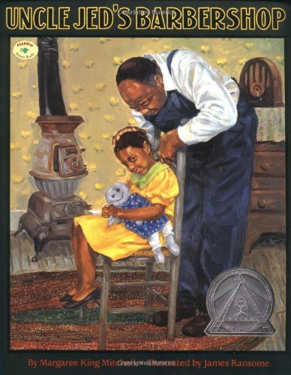

Write a paragraph using 5 or more sentences telling about the leadership habits that Uncle Jed demonstrated in the story.